Craig ELlrod

senior cloud security architect

Deploying Armor Agent with N-Able

N-Central

Table of Contents

Introduction 3

Prerequisites 3

How it works 3

Create Automation Manager .amp File 4

Step 1 – Log into the Armor Portal to grab the Windows Installation Script and License Key 4

Step 2 – Log Into N-Central and start the Automation Manager 5

Step 3 – Select New Policy 6

Step 4 – Select Input in Policy Builder 6

Step 5 – ADD an Input Parameter 7

Step 6 – Search for PowerShell Script 8

Step 7 – Select Add 🡪 the Armor License Input Parameter. 9

Step 8 – Select the Script Tab and Edit 10

Step 9 – Paste the Armor Installation Script into the “Script” window 11

Step 10 – Save the Armor Installation Policy 12

Step 11 – Upload the Armor Installation Policy 12

Create Scheduled Task in N-Central 13

Step 12 – Navigate back to the N-Able N-Central Web Browser Interface 13

Step 13 – Navigate to Configuration 🡪 Profiles 13

Step 14 – Add Task Name 14

Step 14 – Select the ArmorInstall Repository from the Automation Manager 14

Step 15 – Select the ARMOR-LICENSE-KEY input parameter 15

Step 16 – Select Save 16

Create Automation Rule in N-Central 16

Step 17 – Navigate to Monitoring 🡪 Rules 🡪 Add 16

Step 18 – Give the Rule a name 🡪 ARMOR-CLOUD-SECURITY-INSTLSL-RULE 17

Step 19 – Navigate to the Scheduled Task Profiles tab 18

Step 20 – Navigate to the Select Customers tab 18

Enter Armor License Key for each Customer 19

Step 21 – Navigate the All Devices view from the SO or MSP level. 19

# Introduction

This ARMOR Defense field guide will present a step-by-step method to deploy the Armor Agent automatically using the automation tools within N-Able’s N-Central platform.

## Prerequisites

An account with N-Able N-Central access.

<https://n-able.com>

An Armor Management Portal account – Managed Service Provider

<https://amp.armor.com>

The github for this tutorial.

<https://github.com/surfd4wg/armor_NAble>

The scripts for this tutorial.

ArmorAgentInstall.ps1

ArmorInstall.amp

Note: The N-Able automation scripts and platform do not work with MAC OSX.

Additionally, there is a distinction with N-Able where they refer to the Managed Service Provider (MSP) account as the Service Organization (SO). Some illustrations in this document will refer to the “SO” or “MSP”, while other illustrations will refer to the MSP’s or SO’s customer, as “Customer”.

## How it works

Installing the Armor Agent for Windows through N-Able N-Central, involves these simple steps.

* Create an automation policy .amp file in N-Able Automation Manager
* Create a task profile in N-Central that uses the automation policy
* Create an automation rule in N-Central
* Assign the Armor License to each customer in N-Central

# Create Automation Manager .amp File

### Step 1 – Log into the Armor Portal to grab the Windows Installation Script and License Key

The preferred method of installing the Armor Agent into a Windows machine, is by executing the installation PowerShell script in a Windows PowerShell shell.

Log into the Armor Management Portal and copy the Windows installation PowerShell script.

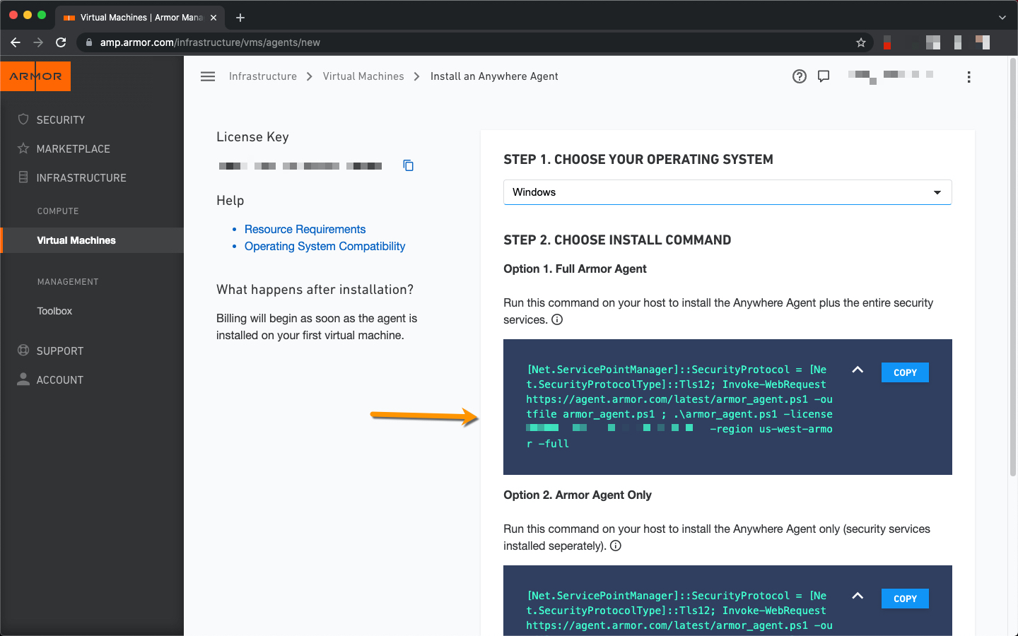

Note: Paste the PowerShell script into a text editor, as we will turn the license key into a scripting variable in N-Central.

Add the following to the main.tf terraform file. Replace the license key placeholder XXXXX-XXXXX-XXXXX-XXXXX-XXXXX with your AMP license key.

Note: The PowerShell installation script can be found by logging into the Armor Management Portal (<https://amp.armor.com>) and navigating to Infrastructure 🡪 Virtual Machines 🡪 + sign. Click on the shield. Select the Windows operating system. For reference the PowerShell installation script is as follows:

﻿[Net.ServicePointManager]::SecurityProtocol = [Net.SecurityProtocolType]::Tls12; Invoke-WebRequest https://agent.armor.com/latest/armor_agent.ps1 -outfile armor_agent.ps1; .\armor_agent.ps1 -license XXXXX-XXXXX-XXXXX-XXXXX-XXXXX -region us-west-armor -full

### Step 2 – Log Into N-Central and start the Automation Manager

Navigate to the SO level (Top Level) of N-Central, and launch the Automation Manager.

﻿

### Step 3 – Select New Policy

### Step 4 – Select Input in Policy Builder

### Step 5 – ADD an Input Parameter

Create the parameter with the following fields

Name: inputARMORlicense

Display: Input Armor License

Type: Password

Value: <empty>

Click on ‘Ok’, then ‘Ok’.

### Step 6 – Search for PowerShell Script

In the left navigation search for “Run PowerShell”, then drag that script to the middle bar between Input and Output.

### Step 7 – Select Add 🡪 the Armor License Input Parameter.

### Step 8 – Select the Script Tab and Edit

### Step 9 – Paste the Armor Installation Script into the “Script” window

Note: Make sure the Armor License Key XXXXX-XXXXX-XXXXX-XXXXX-XXXXX with the parameter we just created ex: $inputARMORlicense.

Note: Use the following PowerShell script, which can also be found on the GitHub site.

[Net.ServicePointManager]::SecurityProtocol = [Net.SecurityProtocolType]::Tls12; Invoke-WebRequest https://agent.armor.com/latest/armor_agent.ps1 -outfile armor_agent.ps1 ; .\armor_agent.ps1 -license $inputARMORlicense -region us-west-armor -full

### Step 10 – Save the Armor Installation Policy

### Step 11 – Upload the Armor Installation Policy

# Create Scheduled Task in N-Central

### Step 12 – Navigate back to the N-Able N-Central Web Browser Interface

### Step 13 – Navigate to Configuration 🡪 Profiles

Select Add 🡪 Automation Policy

### Step 14 – Add Task Name

### Step 14 – Select the ArmorInstall Repository from the Automation Manager

### Step 15 – Select the ARMOR-LICENSE-KEY input parameter

### Step 16 – Select Save

# Create Automation Rule in N-Central

### Step 17 – Navigate to Monitoring 🡪 Rules 🡪 Add

### Step 18 – Give the Rule a name 🡪 ARMOR-CLOUD-SECURITY-INSTLSL-RULE

Select Windows Servers, Workstations and Laptops

### Step 19 – Navigate to the Scheduled Task Profiles tab

Select the Scheduled Task Profile created in the previous section.

### Step 20 – Navigate to the Select Customers tab

Select which customers you want to have this policy turn on for

Click ‘Save’.

# Enter Armor License Key for each Customer

### Step 21 – Navigate the All Devices view from the SO or MSP level.

Click on Custom Properties, for each customer. Enter the Armor License key for each customer.

